18 February 2026

NAME: FADILA ABDULLAHI | Age: 20y | Sex: F
Clinical Details: USG Pelvic

REAL TIME PELVIC ULTRASONOGRAPHY EXAM: REVEALED:

URINARY BLADDER: Distended with urine with normal mucosal thickness. No gross masses or stone seen.
UTERUS: The uterus is gravid and shows single live foetus in the uterine cavity. The cervical Os is closed. Right and Left adnexa are free.
PRESENTATION : Mobile
PLACENTA : POSTERIOR
BPD : 35 mm
EGA : 17 weeks 03 day(s)
EDD : 29/07/2026 (± 2 weeks)

CUL-DE-SAC: No sonographic abnormalities detected in anterior and posterior cul-de-sac.

CONCLUSION: Single live foetus at 17 weeks 03 day(s) GA.

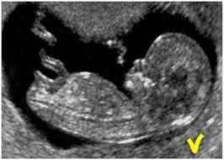

SONOGRAPHER

